**Project Report**

**1.Introduction:**

**1.1 Overview:** The means easy to know the health advantages,quality,ingredients,benefits and how to make the dark chocolates for our health.

**1.**2 **Purpose:** Dark chocolate may help lower the risk of heart disease reduce inflammation and insulin resistance,increase the diversity of the gut microbiome,and improve brain function.

**2.Problem definiton**:

**2**.1 **Empathy map**:

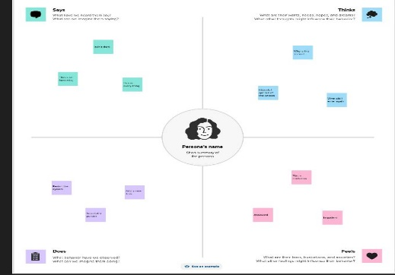

**2.2 Brainstorming:**

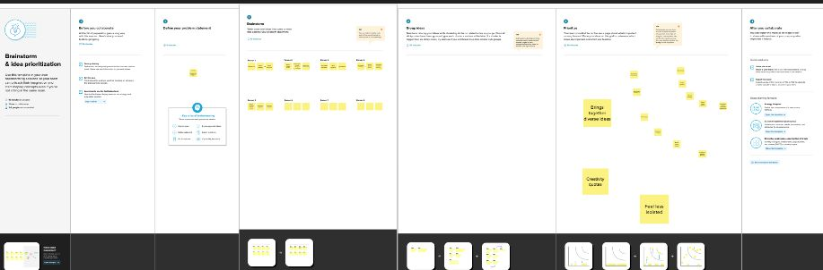

**3. Result:**



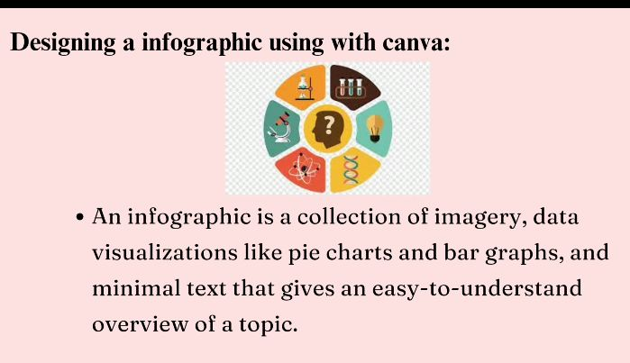

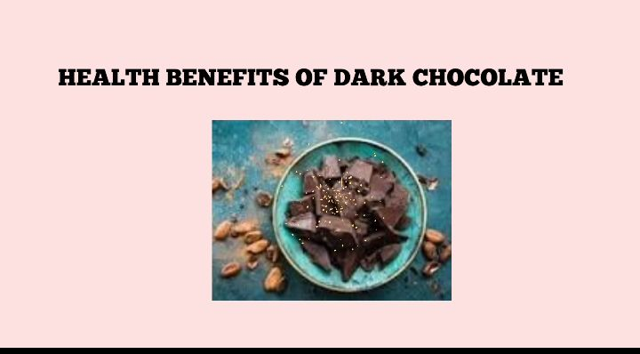

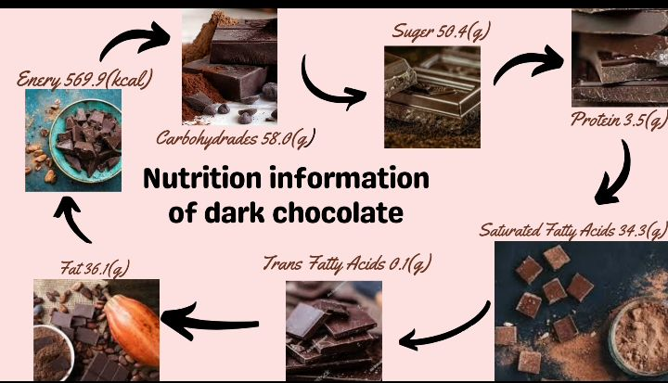

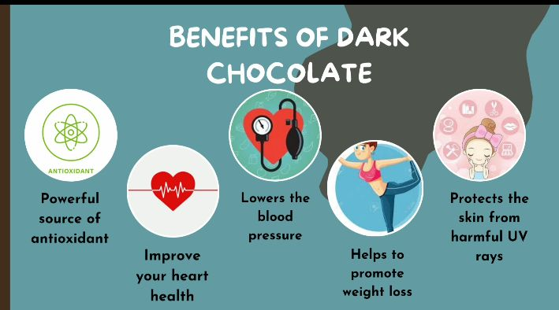

**4. Advantages and disadvantages:**

* Could improve brain function.
* May protect your skin from the sun.
* May reduce your heart disease risk.

**5. Application:**

One of the most signifiant benefits of canva is the unlimited access to premium templates and assets.In that we took chocolate templates.When we are eat dark chocolates reduced their stress and depression.

**6. Conclusion:**

The purpose of our lives to be happily and to make a sweet memories so each of every situation we eat dark chocolates to make a sweetest memories.